ECE 9305A: Introduction to Probability Theory I
Name: B. G. H. Sunanda Gamage
Email: sgamage2@uwo.ca
Student ID: 250992128

Homework Assignments
[Each homework assignment begins on a new page]

Homework 1 (2018/09/19): Simulating the frequentist definition of probability
- Generate N binary digits with, for N = 10, 100 ...
- Observe the relative frequencies (F) of the two outcomes, 1 and 0 (table below).
Outcome | N = 10  Relative freq. | N = 100  Relative freq. | N = 1000  Relative freq. | N = 10000  Relative freq. | N = 100000  Relative freq.
1 | 0.9 | 0.89 | 0.859 | 0.8603 | 0.8599
0 | 0.1 | 0.11 | 0.141 | 0.1397 | 0.1401

- It was observed that as this experiment was repeated with increasing N, the two relative frequencies got closer and closer to the original probabilities .
- At around N = 100000, the changes to the relative frequencies as N was doubled (to 200000) were very small (~0.0001).
- Therefore, N = 100000 was considered as the infinity for which the following quantity approaches the limit. This quantity is the probability of the outcome according to the frequentist definition of probability.

Homework 2 (2018/09/26): Probability of n number of 1’s in a binary string of length N
- A binary digit string of length N is generated (consider cases N = 8, 16, 32). , .
- Part 1: the theoretic probability of having exactly n number of 1’s in this string is given by

- This probability is calculated and plotted for below .
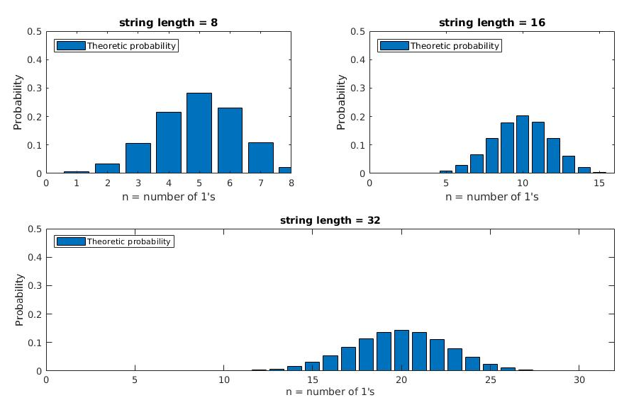
- Part 2: the probability of having exactly n number of 1’s in the string is estimated experimentally by generating a large number of strings (10000 trials in this experiment), and counting the number of 1’s in the string in each trial.
- The probabilities estimated in this way are plotted against the theoretic values in the graph below (next page).
- We can clearly see that the theoretic values and the experimental values are approximately equal. It was also seen that when the number of trials was increased to 1 million, the experimental values got even closer to the theoretic values.

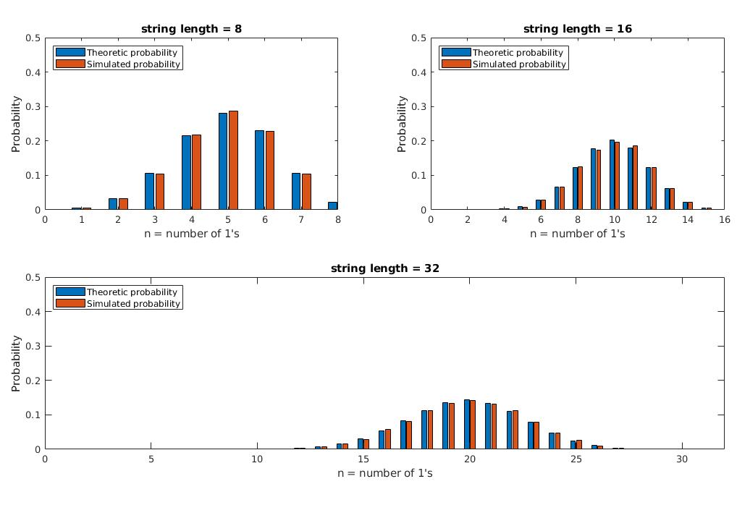

Homework 3 (2018/10/03):

